BANKING MANAGEMENT SYSTEM

*A Project Based Learning Report Submitted in partial fulfilment of the requirements for the award of the degree*

*of*

**Bachelor of Technology**

**in The Department of CSE**

FULL STACK APPLICATION DEVELOPMENT  
(23SDC12A)

Submitted by

**2310030110: Akhil Vutla**

**2310030109: Harshavardhan**

**2310030213: Ahsan**

**2310030325: Shivaanjan**

Under the guidance of

**DR . A . Shiva Krishna Reddy**



Department of Computer Science and Engineering

Koneru Lakshmaiah Education Foundation, Aziz Nagar

Aziz Nagar – 500075 (Optional)

NOV - 2023.

**Abstract**

**The Banking Management System is a web-based full-stack application designed to streamline and secure online banking operations for users and administrators. Built using the MERN stack—MongoDB, Express.js, React.js, and Node.js—this system enables core banking functionalities like user registration, authentication, account balance management, transaction processing, and custom report generation.**

**The application replaces traditional banking procedures with a modern digital interface, allowing users to log in securely, view their dashboard, transfer funds, and review transaction histories. MongoDB serves as the primary database, offering flexibility and scalability to manage a wide range of user and transaction data. React.js powers the frontend for a dynamic and responsive user experience, while Express.js and Node.js handle the backend logic, API endpoints, and interaction with the database.**

**Security is enforced using JWT-based authentication and OTP verification during sensitive operations like fund transfers. Admin users can oversee account activities, generate reports, and ensure smooth banking operations.**

**This project not only simulates essential banking services but also demonstrates the implementation of secure, modular, and scalable software design using modern web technologies. It is an ideal system for learning full-stack development in a real-world financial context.**

**List of Figures**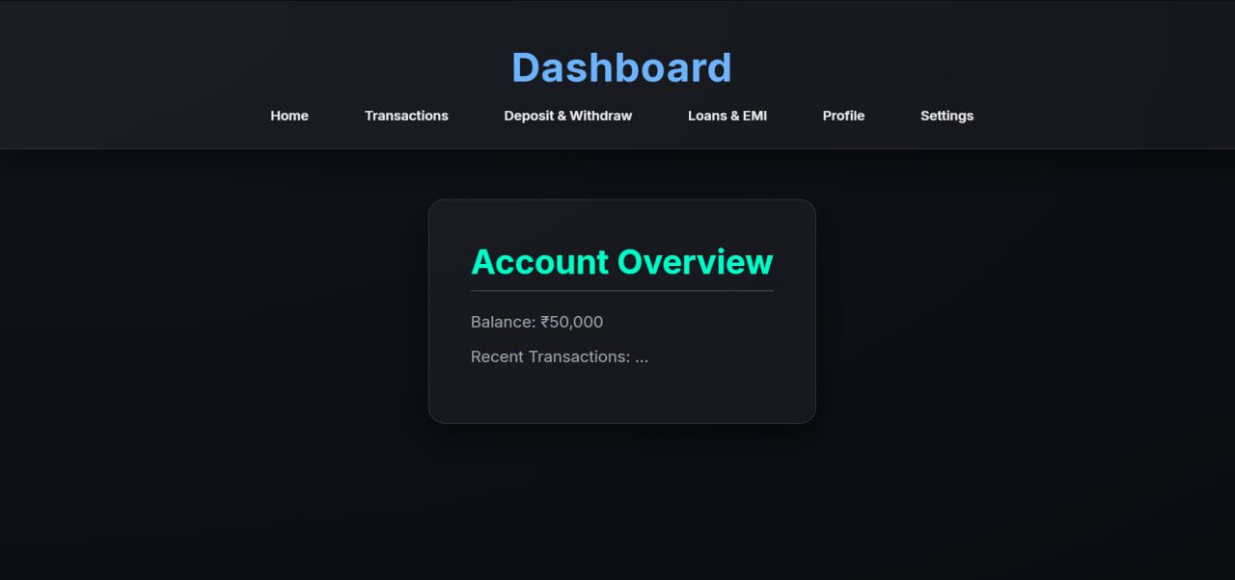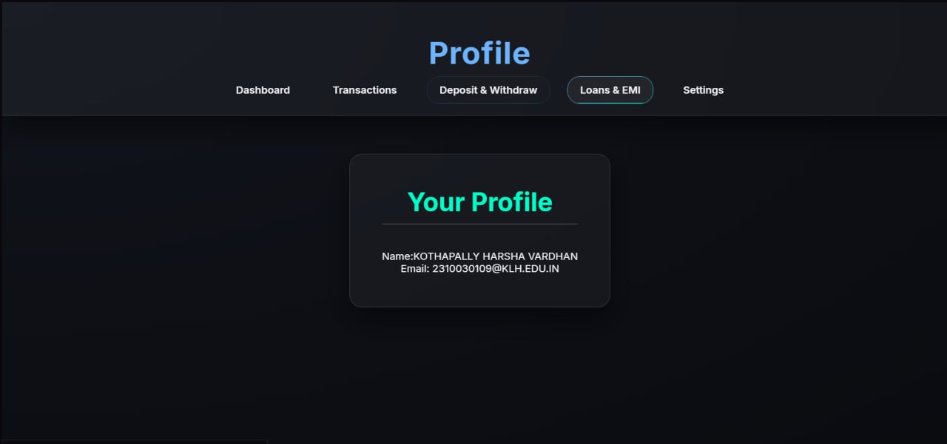

BANKING MANAGEMENT SYSTEM

# **Introduction**

The **banking management system** is designed to streamline banking operations, enhance customer service, and improve overall institutional efficiency. It serves as a centralized and integrated platform that consolidates all essential banking functions into a single, user-friendly interface. By automating and digitizing routine banking tasks, this system significantly reduces manual effort, minimizes errors, and saves valuable time for both bank employees and customers. Key features of the platform include real-time transaction monitoring, efficient account management, secure loan processing, and structured financial reporting tools. In addition, the system promotes better communication across departments, ensures compliance with regulatory standards, and provides insightful data analytics to support strategic decision-making. Overall, the banking management system plays a crucial role in enhancing customer satisfaction, operational productivity, and the long-term growth of the financial institution.

# **METHODOLOGY**

* **1. Requirement Gathering**
* Identified core features:
  + **User Registration/Login**
  + **Account Dashboard**
  + **Transaction History**
  + **Fund Transfer**
  + **OTP Verification**
* Defined roles: **Admin** and **User**
* **2. System Design**
* **Frontend:**
  + Built using **React.js** with Tailwind CSS / Bootstrap for responsive UI.
  + Includes dashboards, modals for transactions, and history views.
* **Backend:**
  + Built using **Node.js** with **Express.js** to create RESTful APIs.
  + Handles business logic like fund transfer, account validation, OTP generation.
* **Database:**
  + Used **MongoDB** (NoSQL) to store:
    - User data (account number, name, email)
    - Transactions (amount, type, timestamp)
    - OTPs (with expiry)
* **3. Implementation**
* **Frontend** connects to backend via **Axios** for:
  + Login/Register
  + View Balance
  + Initiate Transactions
  + View Transaction History
* **Backend API** performs:
  + Authentication using **JWT**
  + Data validation and encryption
  + CRUD operations on MongoDB via **Mongoose**
* **4. Testing**
* Unit testing with **Jest** (Node) and **React Testing Library**
* API testing using **Postman**
* Manual testing for:
  + Transaction scenarios
  + OTP flows
  + Edge cases (insufficient balance, invalid user)
* **5. Deployment**
* **Frontend:** Deployed on **Vercel / Netlify**
* **Backend:** Hosted using **Render / Railway / Heroku**
* **Database:** Hosted with **MongoDB Atlas** (cloud)
* **6. Maintenance & Scalability**
* Modular codebase for adding features (bill payments, mobile banking)
* Scalable NoSQL structure to handle large user data
* Future support for **mobile version** using React Native

# **EXPERIMENTS**

To evaluate the functionality and effectiveness of the **Banking Management System**, several experiments were conducted across different modules. The transaction monitoring feature was tested by simulating various account activities, including deposits, withdrawals, transfers, and account balance inquiries. The system accurately recorded and updated transactions in real time, generating comprehensive reports with complete audit trails. The account management module was validated by creating and managing different types of accounts, updating customer information, and testing account closure processes. All operations were executed smoothly, with proper validations and error handling. For the loan processing system, applications were submitted with varying loan types, interest rates, and repayment schedules. The system effectively processed applications, calculated EMI plans, and tracked payment histories, ensuring transparency and accuracy. The financial reporting tools were tested by generating balance sheets, profit and loss statements, and regulatory compliance reports. The outputs matched expected results, confirming the system’s reliability. Overall, the experiments demonstrated the system's efficiency in streamlining banking operations, ensuring data integrity, and enhancing overall user experience.

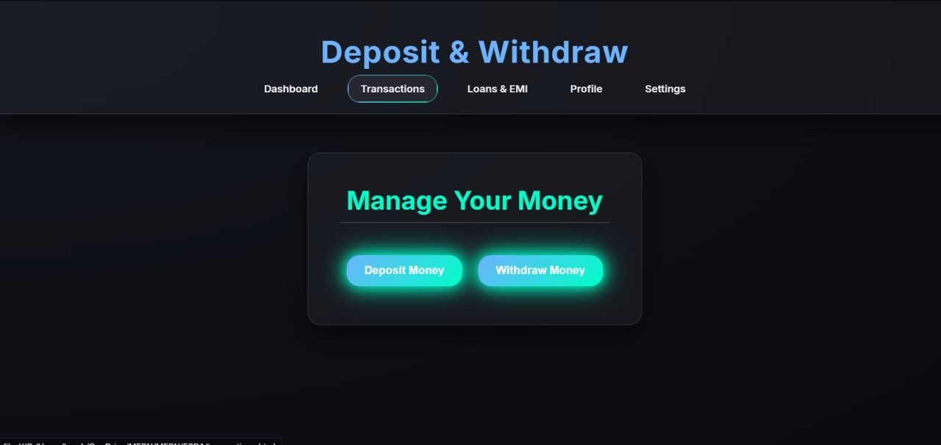

**REFERRENCE**

1. Oracle. (n.d.). **Banking Software Solutions**. Retrieved from  
   <https://www.oracle.com/industries/financial-services/>
2. SAP. (n.d.). **SAP for Banking: Digital Banking Solutions**. Retrieved from  
   <https://www.sap.com/industries/banking.html>
3. Infosys. (n.d.). **Core Banking Solutions**. Retrieved from  
   <https://www.infosys.com/industries/financial-services/offerings/core-banking.html>

# **RESULTS**





# **CONCLUSION and FUTURE WORK**

**The Banking Management System is a comprehensive and integrated solution designed to optimize and automate essential banking operations within a financial institution. By incorporating features such as real-time transaction monitoring, customer account management, loan processing, compliance tracking, and financial reporting, the system significantly reduces manual workload and enhances operational efficiency. It empowers banking staff with intuitive tools and provides management with actionable insights to support data-driven decision-making. The platform fosters seamless communication across departments, ensures regulatory compliance, and enhances customer satisfaction through faster and more reliable services. As the banking industry continues to evolve with technological advancements and shifting customer expectations, such systems play a critical role in driving innovation, ensuring scalability, and securing long-term institutional growth and competitiveness.**